|  |
| --- |
|  |
| Capstone Project Document |

**Outsourcing Human Resource Management**

Report #1 – Project Introduction

|  |  |  |
| --- | --- | --- |
| **Dandelion** | | |
| **Group Members** | Nguyễn Hữu Phước | SE61138 |
| Nguyễn Thị Xuân Mai | SE60910 |
| Ngô Trắc Kiện | SE61016 |
| Trần Quốc Hiệp | SE60928 |
| Đỗ Thanh Dương | SE61191 |
| **Supervisor** | Mr. Nguyễn Văn Sang | |
| **Project code** | OHRM | |

**- Hanoi, 01/2016 –**

# SIGNATURE PAGE

AUTHOR: Nguyễn Thị Xuân Mai 19/01/2016

Team member

REVIEWERS: Nguyễn Hữu Phước

Project manager

APPROVAL: Nguyễn Văn Sang --/--/--16

Supervisor

Record of change

*A - Added M - Modified D – Deleted

|  |  |  |  |  |  |
| --- | --- | --- | --- | --- | --- |
| Effective Date | Changed Item | A,M,D | Change Description | Reason for Change | Rev. Number |
| 19/Jan/2016 | Create Introduction | A | Create Introduction | First version | 1.0 |
|  |  |  |  |  |  |
|  |  |  |  |  |  |
|  |  |  |  |  |  |
|  |  |  |  |  |  |
|  |  |  |  |  |  |
|  |  |  |  |  |  |
|  |  |  |  |  |  |
|  |  |  |  |  |  |
|  |  |  |  |  |  |
|  |  |  |  |  |  |
|  |  |  |  |  |  |
|  |  |  |  |  |  |
|  |  |  |  |  |  |
|  |  |  |  |  |  |
|  |  |  |  |  |  |
|  |  |  |  |  |  |
|  |  |  |  |  |  |
|  |  |  |  |  |  |
|  |  |  |  |  |  |
|  |  |  |  |  |  |
|  |  |  |  |  |  |
|  |  |  |  |  |  |
|  |  |  |  |  |  |

Table Contents

SIGNATURE PAGE 1

1 INTRODUCTION 3

1.1 Purpose 3

1.2 Acronyms and Definitions 3

2 ABSTRACT 3

3 LITERATURE REVIEW 3

4 PROPOSAL 4

4.1 The idea 4

4.2 Objectives 4

4.3 Brief description about system 4

4.4 System features 5

4.4.1 Resource manager features 5

4.4.2 HR features 6

4.4.3 Admin features 6

5 BENEFIT FROM PROJECT 6

5.1 For our group 6

5.2 For resource manager 6

6 CRITICAL ASSUMPTION AND CONSTRAINTS 7

7 POTENTIAL RISKS 7

8 REFERENCES 7

# INTRODUCTION

## Purpose

This document is created as the introduction for project Outsourcing Human Resource Management – our Capstone Project at FPT University. In this document, we will descript the overview of some existing systems, the initial idea for our project, a brief description about our expected system and some potential risks, critical assumptions, constrains. Moreover, this document also shows opportunities what it offers for users.

## Acronyms and Definitions

|  |  |
| --- | --- |
| Acronym & Abbreviation | Definition |
| OHRM | Outsourcing Human Resource Management |
| FU | FPT University |
| HR | Human Resource |

**Table 1:** Definitions and Acronyms

# ABSTRACT

Due to the development and growing size of the software outsourcing company, human resource management for each project is important.

Human resource management in an outsourcing software’s company isn’t simple as manage engineers but also ensure to assign work for engineers with matched level and skills to projects.

Thus, the development of specialized management system for human resource involve in specific projects are needed.

OHRM is a system like that. It helps reducing the management pressure for resource manager to improve the productivity of works of engineer and project.

In addition, resource manager can organize their engineer resource for planning project.

# LITERATURE REVIEW

Nowadays, there are a lot human resource management system in different fields are available on internet and users can easily access to it but for outsourcing field it still may not have it yet.

* **FSOFT Human Resource**

The systems provide management specialized functions in outsourcing HRM software such as employee records and assign employees into projects ….

* **Advantages:**
* High security.
* Easy to use.
* Only people with authority can access to it.
* **Disadvantages:**
* Not available online because it’s a private software.
* Planning project and annual report still be done by excel.
* Request recruitment through email.

# PROPOSAL

## The idea

Recognizing that many problems existed, there are number of solutions OHRM system give. System will provide functions that focus on assign resource, manage resource for each specific project, request recruitment ….

## Objectives

This project is the Capstone Project in FPT University studying program.

First, this project is responsibility for all team members. So we must complete all requirements from teacher and FU. During the time doing project, we can learn how to develop a project, how to manage project, how to communicate better between team member, how to control time, how to perform teamwork effectively. Moreover, we also have experience in Java technology, website designing, software testing. Therefore, we think this project is very necessary for us to improve skills, knowledge which we studied in FU. This project also makes our CV more fascinating after graduating from FU. This is also an opportunity for us to prove capacity with headhunters.

Furthermore, we develop and deliver innovative human resource programs to support the most of outsourcing company's most valuable resource - its engineers. We are committed to provide resource manager and human resource department a stable work environment. With suggestion system are designed for improving the effectiveness of using engineer resource. Above all, It’s about having the right people, with right abilities, in the right place, at the right time.

## Brief description about system

To manage that resource outsourcing, we build a system that supports human resource management in the projects. Helping resource manager plans resource for project with resource through time.

OHRM uses familiar technologies as: Java, MVC, Bootstraps, JQuery…

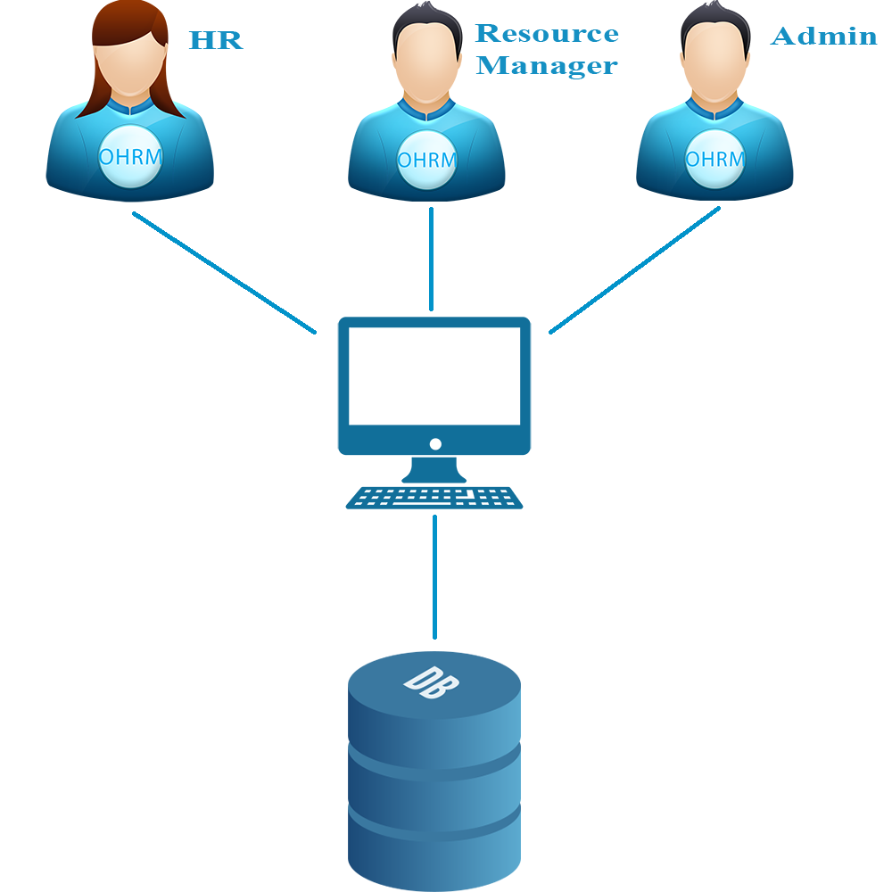

**Figure 1:** Brief descriptions diagram of OHRM system

## System features

About the features of OHRM, we focus to provide for Resource manager main features as create project, planning project, assign engineer, search project, etc. HR enter engineer information, change recruitment status. Admin can manage account.

In here, we focus on features which can help resource manager and HR can understand the best way what they can do with features of OHRM. There are the detailed features of OHRM:

### Resource manager features

* Project
  + Create New Project: Resource manager can create new projects with basic info.
  + Edit Project: Resource manager can change and update information of projects which created.
  + Search Project: Resource manager can search project with some filter.
  + Assign engineer: System suggest engineer based on project information then resource manager can assign engineer.
* Recruitment:
  + Request recruitment: Resource manager can make the request depend on the lack of resource of company.

### HR features

* Recruitment:
  + Search recruitment: HR can search can search project with some filter.
  + Change recruitment information: Change requirement status and update progress recruitment.
* Engineer information:
  + Enter engineer information: HR will enter all engineer information into system.

### Admin features

* Account:
* Create account: Admin can create account.
* Edit account: Admin update account information.
* Deactivate account: Admin can deactivate account.

# BENEFIT FROM PROJECT

## For our group

After developing and implementing this project, our group will get some benefits:

* Have more experiences of software project management how to manage plan, time, member and risk.
* Have more knowledge and skill about Java and JQuery programming.
* Know how to communicate with team members and how to teamwork more effective.

## For resource manager

Just need to have a device that connect to the internet and any web browser, resource manager can:

* Easy to create a project.
* Easy to plan a project.
* Easy to assign engineer to project.

# CRITICAL ASSUMPTION AND CONSTRAINTS

* Critical assumption:
  + Training: All developers can train Java and JQuery in 2 weeks. With programming techniques which we studied at FU, we have to try the best to not missing any deadline in project plan.
  + Human resources: Assume that all members in team have a good healthy to do their tasks.
* Constraints:
  + Time and deadline: We must complete task on time. We work on 14 weeks, each member works 5 hours/day and 5 days/week. We do not have more time for us to complete developing and deliver application to teachers. Besides, we have to submit report documents before deadline to teacher can review.
  + Quality: The products must be run well when users perform main functions in Google Chrome 40 and Firefox 30 or higher.
  + Process: We have to follow the software processing of FPT Software
  + Human resources: There are 5 members in our team, just 2 members still have to study at school.

# POTENTIAL RISKS

After studying about this project, we find out some problem that we may be encountered:

* Under-estimate scope and time or miss deadline because lack of experience in group working, managing and controlling work.
* Loss data, source code before uploading data to server because of careless.
* Equipment got broken because of careless or accident.
* Human resources: Team member cannot complete their works because of health reasons, key member leave team or un-cooperating on team.
* Change requirements: Requirement changed when some functions cannot be completed or some technologies is not suitable.

# REFERENCES

Our team interview and get requirement from Mr. Nguyen Duc Hien (FSOFT’s company), Mr. Nguyen Minh Y (Master technical of RASIA’s company), Mr. Bui Tan Thach (Team leader of NUS Technology Company) and Mr. Do Duc Tai (Technical leader of CODESPOT Company).